DOWNTOWN AQUATICS SCHEDULE
June 2021

MON | TUES | WED | THURS | FRI | SAT
5:00-8:00 am  Lap Swim | 5:00-8:00 am  Lap Swim | 5:00-8:00 am  Lap Swim | 5:00-8:00 am  Lap Swim | 5:00-8:00 am  Lap Swim | Pool Closed
8:15-9:00 am  Hydro Fit | Pool Closed | 8:15-9:00 am  Hydro Fit | Pool Closed | 8:15-9:00 am  Hydro Fit | Pool Closed
Pool Closed | 9:00-9:45 am  Hydro Fit | Pool Closed | 9:00-9:45 am  Hydro Fit | Pool Closed | 9:15-10:00 am  Aqua Zumba®  AT TUHEY POOL
Pool Closed | Pool Closed | Pool Closed | Pool Closed | Pool Closed
11:30 am-1:30 pm  Lap Swim | 11:30 am-1:30 pm  Lap Swim | 11:30 am-1:30 pm  Lap Swim | 11:30 am-1:30 pm  Lap Swim | 11:30 am-1:30 pm  Lap Swim
Pool Closed | Pool Closed | Pool Closed | Pool Closed | Pool Closed
Pool Closed | Pool Closed | Pool Closed | Pool Closed
Pool Closed | Pool Closed | Pool Closed | Pool Closed
6:05-6:35 pm  Preschool & Parent Child Swim Lessons* | 6:05-6:35 pm  Preschool & Parent Child Swim Lessons* | 6:05-6:35 pm  Preschool & Parent Child Swim Lessons* | 6:05-6:35 pm  Preschool & Parent Child Swim Lessons*
6:40-7:10 pm  Youth Swim Lessons* | 6:40-7:10 pm  Youth Swim Lessons* | 6:40-7:10 pm  Youth Swim Lessons* | 6:40-7:10 pm  Youth Swim Lessons*
7:30-8:30 pm  Masters Swim*  Until June 9 |  | 7:30-8:30 pm  Masters Swim*  Until June 9 | 6:00-10:00 pm  SCUBA*  Until June 10

* Indicates fee-based classes; please contact Chuck Gallatin, Director of Safety & Aquatics, at 741-5541 for more information.
Tuhey Pool Hours of Operation:
5:30-11:00 am Lap Swim
12:00-8:00 pm Open swim
YMCA of Muncie members have free access to Tuhey pool by scanning their membership cards

Please see the back page for details on COVID procedures including capacity numbers, lap swim and class reservations.

What to expect:
- Towel services have been suspended; pool users will need to bring their own towel.
- Participants are not required to wear a mask in the pool. Members are encouraged to wear a mask in all common areas where other members are present. We recommend wearing a mask whenever safely possible to limit the spread of germs.
- All equipment must be cleaned prior to and after use.
- Locker Rentals will be available; please see the front desk for details.
- Appointments are required for some activities, please see below for details.
  - Lap Swim:
    - Participants must reserve an appointment as space is limited due to social distancing. Use the QR code to reserve your spot(s) or call our Member Service Desk at 765.288.4448. *You may register for your one-hour time slots up to one week in advance.
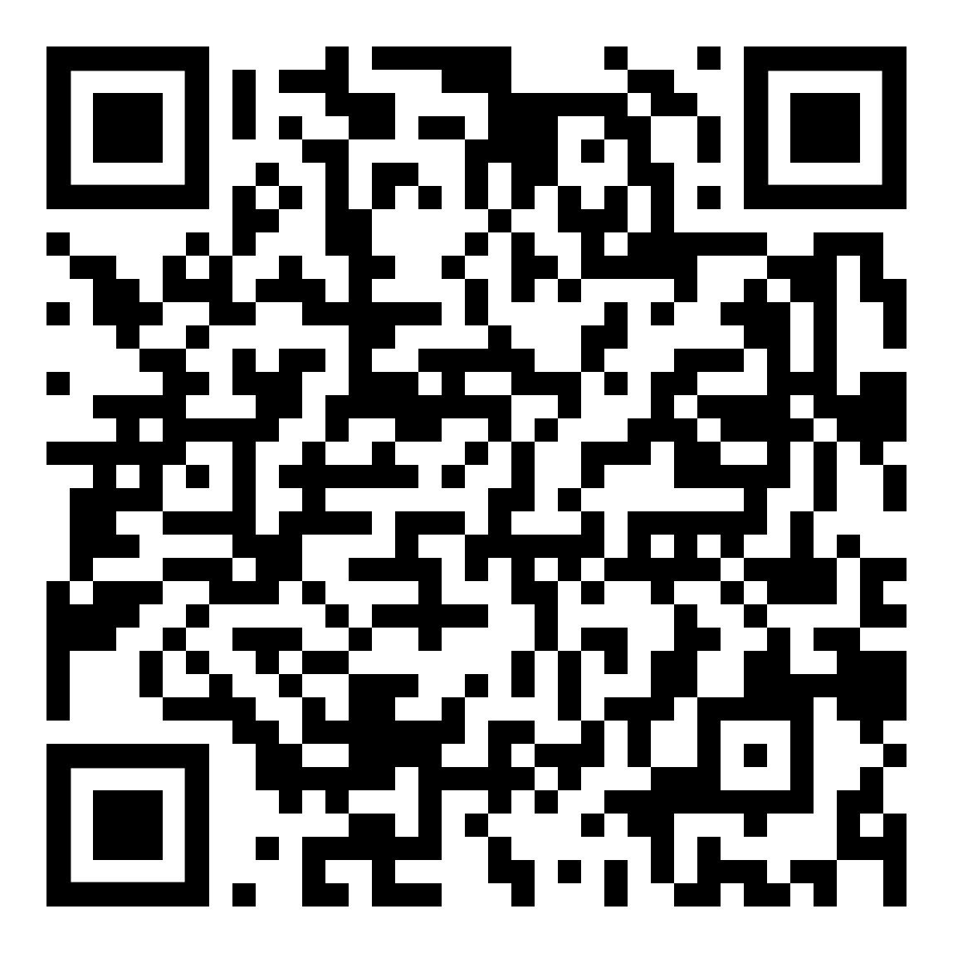
    - Two swimmers will be permitted per lap lane. Swimmers within the same lane will need to rest at opposite ends to ensure social distancing.
    - Two lanes will be available during Open Swim for lap swimming. Lanes during open swim will be available on a first come, first served basis.
  - Water Fitness Classes:
    - Participants must reserve an appointment as space is limited due to social distancing. Use the QR code to reserve your spot(s) or call our Member Service Desk at 765.288.4448. *You may register for your class(es) up to one week in advance.
    - Classes will be limited to 20 participants to allow social distancing.
  - Open Swim:
    - You will not be required to make an appointment for open swim. Open swim times will have a maximum capacity of 23 participants.
    - Equipment, other than lifejackets, will not be available for use during open swim. Participants are permitted to bring their own equipment.
    - Two lanes will be available during Open Swim for lap swimming. Lanes during open swim will be available on a first come, first served basis.

